Standard Operating Procedure (SOP)

Platform Feature Releases
Context | This is the SOP is to deploy Platform features to the Production environment using Release Management.
Purpose | To list steps that Platform Team members must follow to deploy features via Release Management to Production.
High level process overview | This document includes two different deployment options.  Option1: Platform Team will receive an email from the Release Management system requesting approval to production. This email will provide a link to a web page where the approver can approve the request – when approved Release Management will automatically deploy the feature to production.  Option 2: Manually approve the deployment using Visual Studio Release Management console - when approved Release Management will automatically deploy the feature to production.
Roles and responsibilities | This is to be carried out by a Platform Team member who has access to the Release Management application. He/she must be a member of the Release Management Group ‘Platform Team’.
Business rules | - Once a feature has been published to production and assigned to a production container, it can never be updated with another deployment – a new version of the feature must be deployed. EXCEPTION – if a critical bug is fixed, this is the only time a production feature can be updated.  - Deploying a new feature to the production environment does not mean that it is available anywhere to any users. It first needs to be configured into a production container. This drastically reduces the risk of deploying new features into production.  - A feature typically has the following dependencies: static HTML content, themes and a Layer 7 API endpoint. These dependencies should preferably be deployed to production before the feature, although all these pieces are independent. Before the feature is configured into a production container, it must be validated that all the dependencies are ready in production.  - Mission Control is the tool that allows for configuring a feature into a container. Until Mission Control is ready in production (approximately Q3 2015), this task is a DBA task (database scripts need to be deployed to change the configuration). Therefore the database scripts cannot be deployed until all the feature dependencies are ready in production.  - It is possible to validate a new feature in production by assigning it to a container that only testers can access. Testing Services will be responsible for this aspect. This is similar to approving live changes before releasing to the wider user community.  - Until a feature has been assigned to a production container, it supports continuous delivery in the production environment. Therefore it would be considered normal to have many deployments of a feature, in a short amount of time, until the feature is assigned to a production container.  - A feature is defined more specifically as a feature version. So a “Balances” feature could have multiple versions (1, 2, 3…) in production. The feature ID (GUID) and version number appear in the URL of the feature.  - All the details of the feature and its versions sit in the Atlas Platform Services. Without this information in Platform Services, the feature is basically useless in production. These details are currently managed by DBA’s, but will soon be managed using the Mission Control tool.
Procedures | Refer to steps below.

Release Management Deployment Instructions

Deployment Option 1

- Navigate to Release Management email
- Follow the ‘View Request’ link to the Release Explorer page.
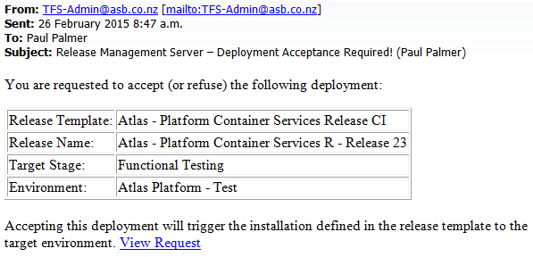

- View deployment history by clicking on the blue boxes at the right of the screen
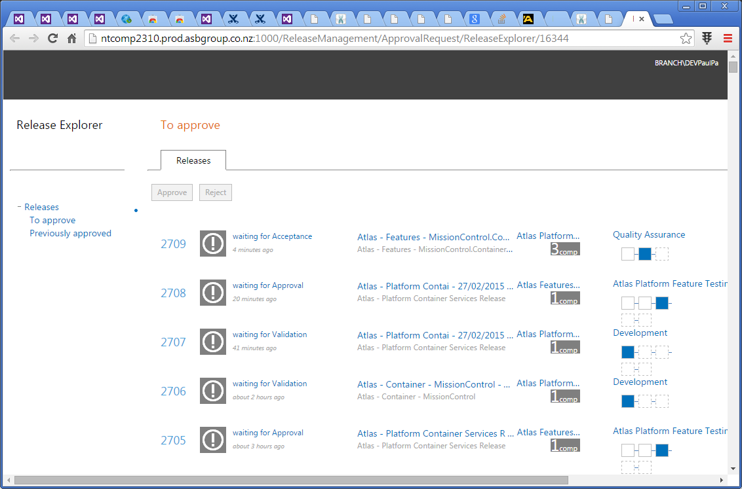
  - *View of deployment history*
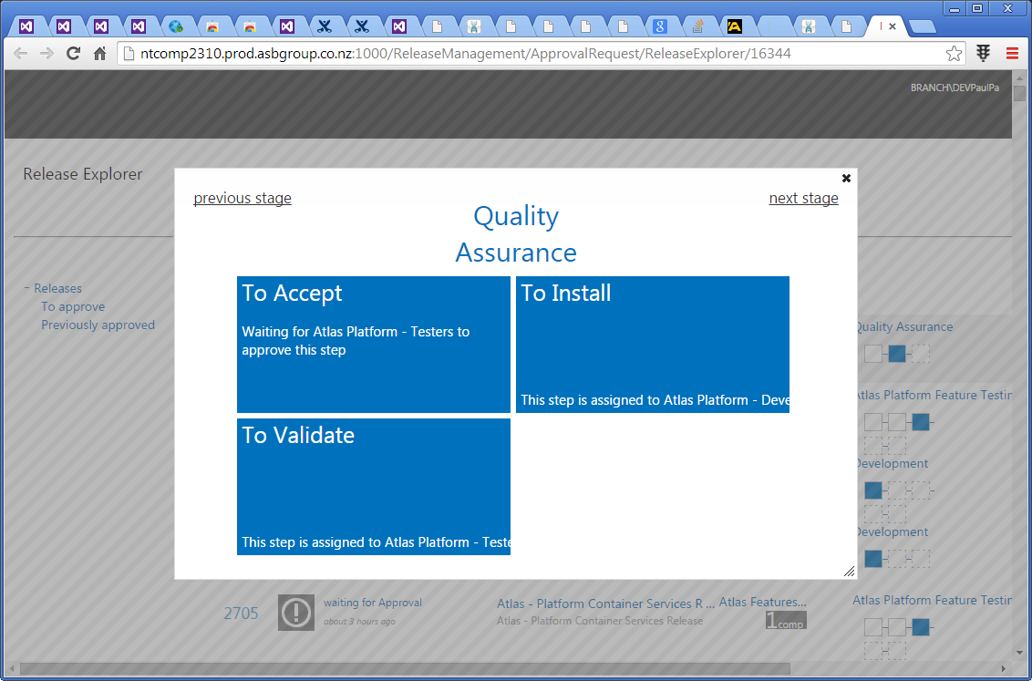

- Select the row that needs accepting in screen 3
- Enter relevant information/ comments
  - Schedule deferred deployment if desired.
  - Click Approve
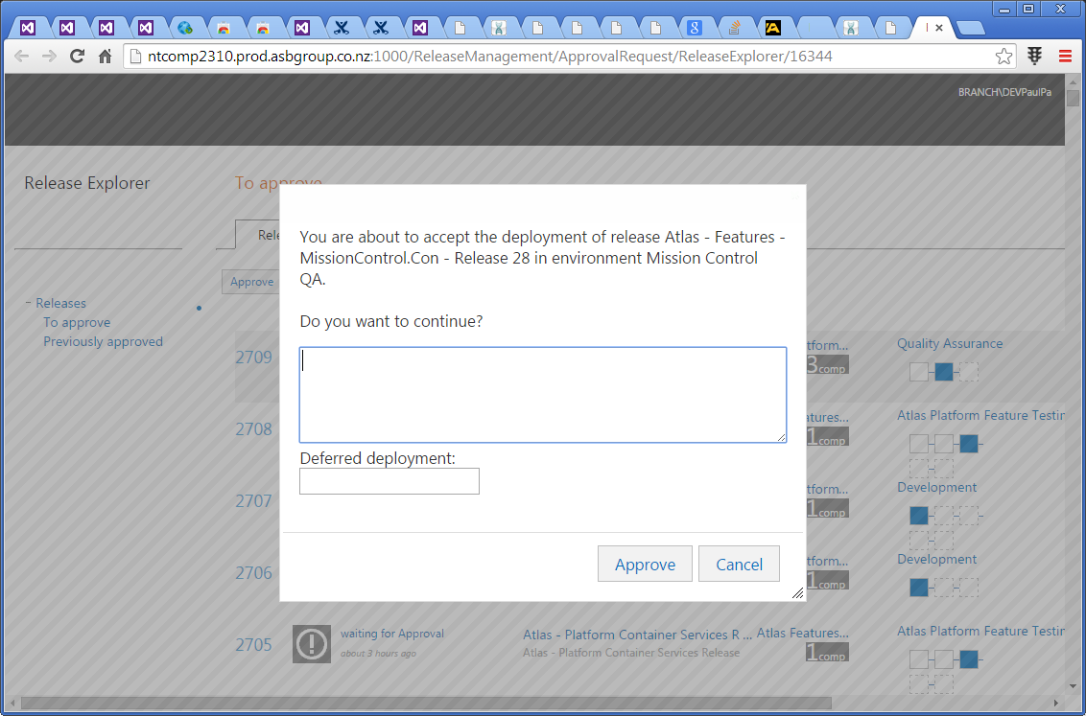

- You should now have a successful deployment

Deployment Option 2
- Navigate to Visual Studio Release Management console
- View Release’s to be approved
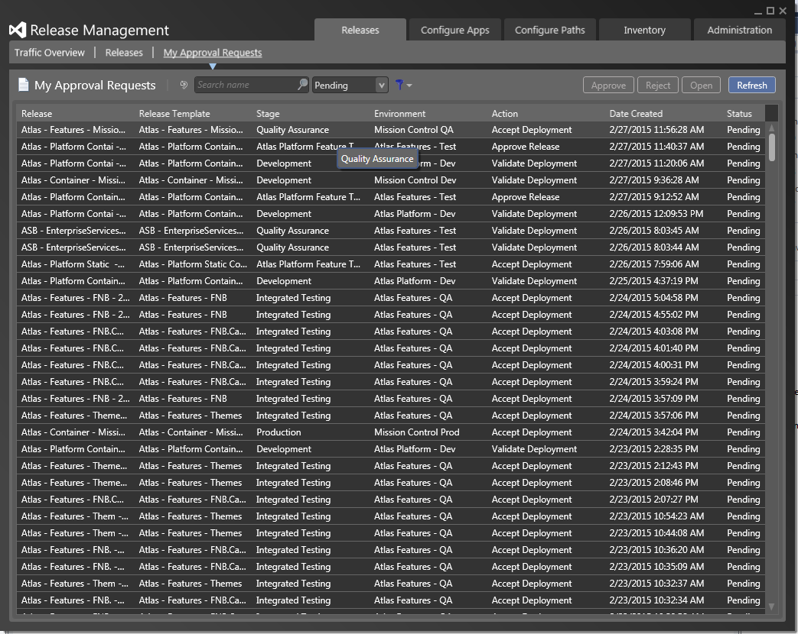
- Select desired release and click Approve
- Enter relevant information/ comments
  - Schedule deferred deployment if desired.
  - Click Ok
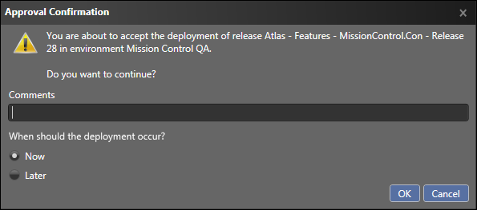

- You should now have a successful deployment

Viewing the deployment log
- In the Release Management Console click on the release tab and select the desired release
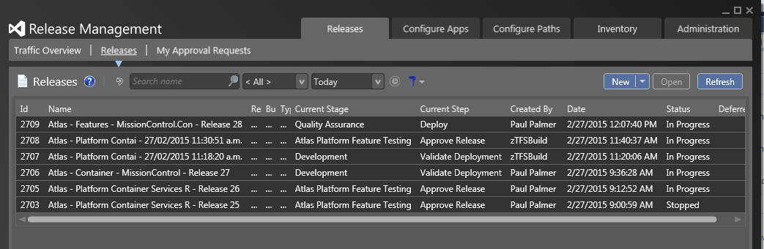

- View current state of release by clicking on the blue bar to the right of the screen
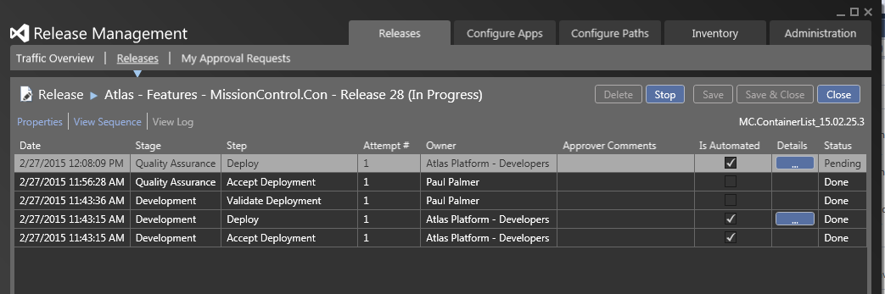

- Click ‘View Log’ to view the deployment log for the step you are currently viewing
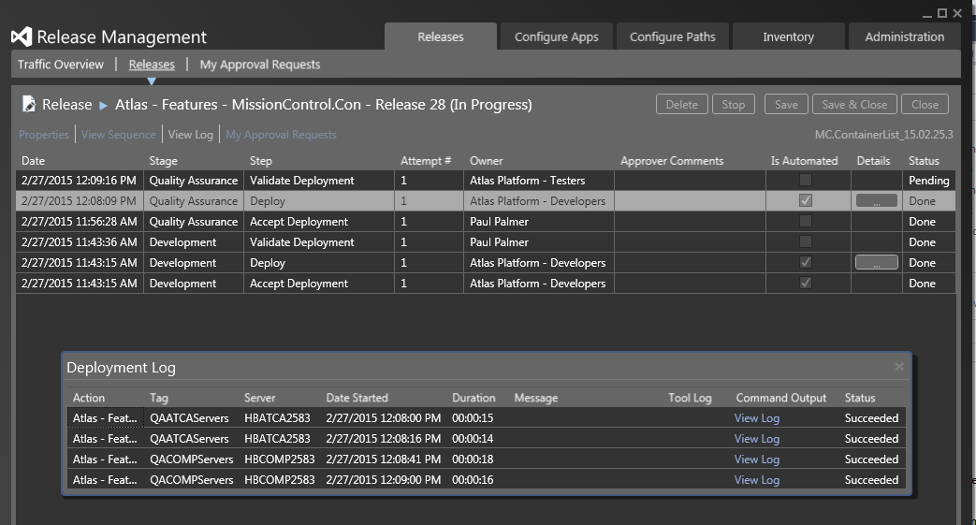

When a release fails
- If the release fails – you will receive an email informing you of the failure
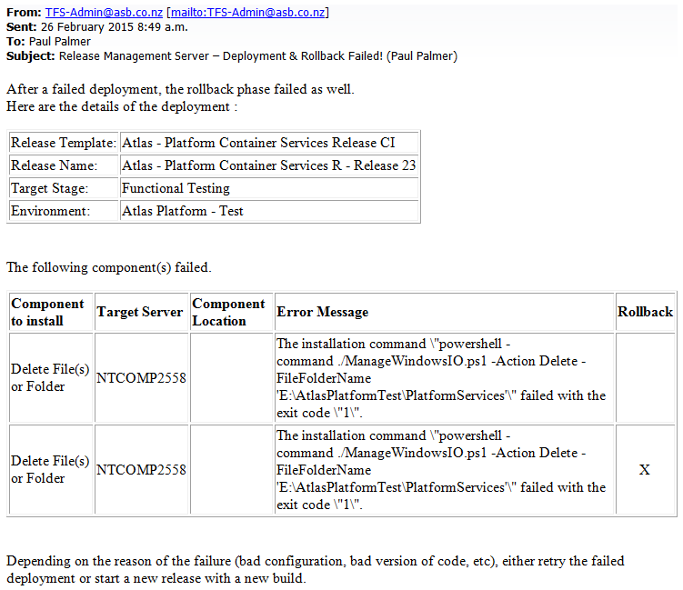

- Navigate to the Deployment log in the Release Manager Console (steps shown above) to view details of the failed release
  - In this example:
    - The web.config file was left open resulting in the deployment not being able to delete the current installation folder. The rollback then also tried to delete the current folder so it could add the backup files back in but that failed too because of the open web.config.
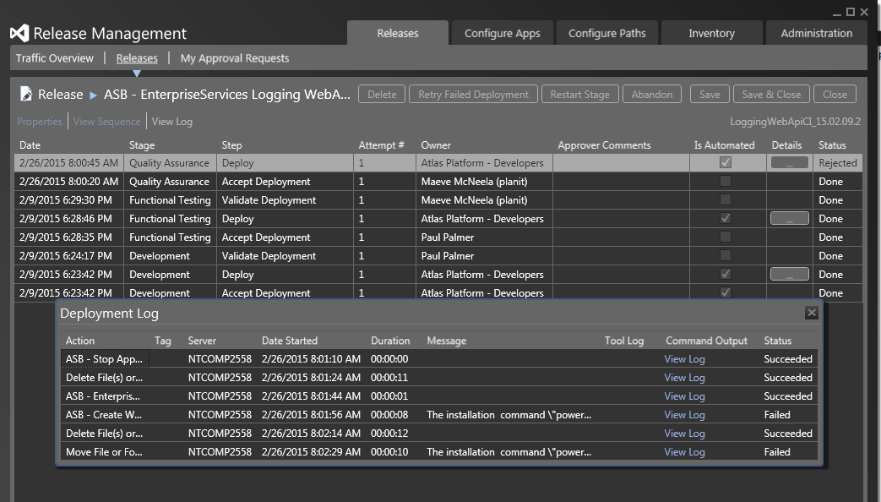
- Retry a failed release by clicking ‘Retry failed deployment’
  - This will attempt to do the deployment steps again

- To restart - click ‘Restart Stage’
  - This will restart deployment from the beginning and will require release acceptance again.

References

Version Control | Procedure Owner | SA Platform Team
Version Number | 1 | Version Date | 2/04/2015
Version Number | 2 | Version Date | 26/05/2015

